1. **Download and install Python**

link- <https://www.python.org/downloads/> and install it.

1. **Install Virtualenv and Django**

Open cmd and run it as administrator

Type command – easy_intsall --version

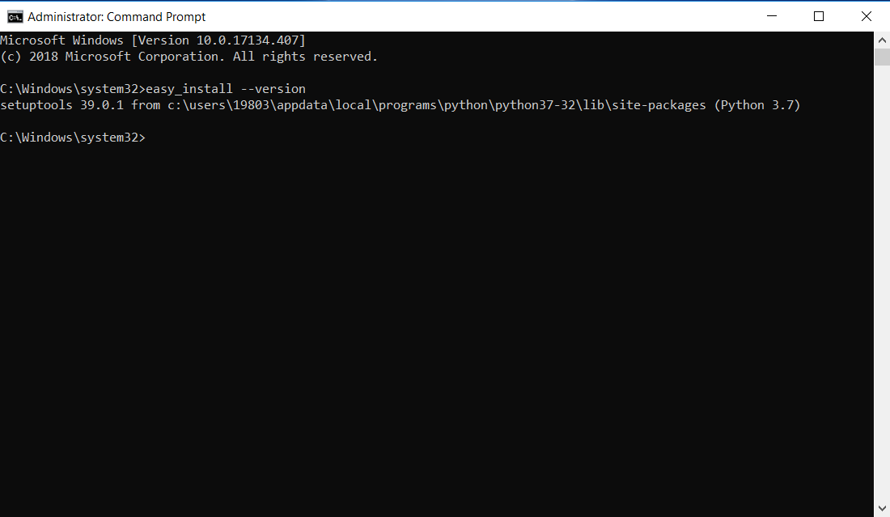

If this line is not returned on the cmd then setup environment variable for the easy_install

Navigate to the folder where python is installed

Go to scripts folder

Copy the file path for easy_install

Right click on my computer and click on properties

Then go to Advanced system settings and click environment variable

Edit the Path string and copy the filepath for easy_install

Click ok and type command on the cmd – easy_install –version

Type command easy_install virtualenv

Navigate to the folder where you want to create the virtualenv

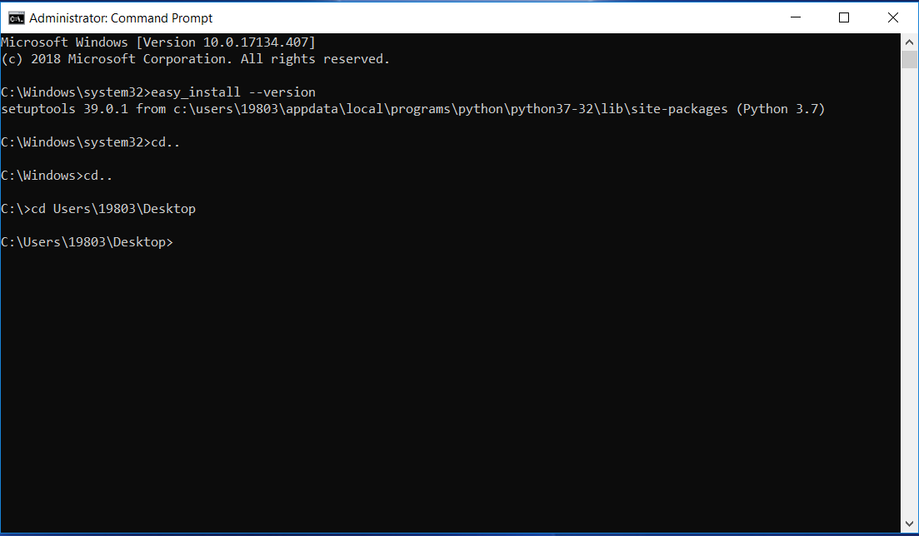

Type command – virtualenv projectrealestate

Here we are creating a vritualenv for the project with project name as pro

To activate the virtualenv follow-

Navigate back to project folder and install Django as follows-

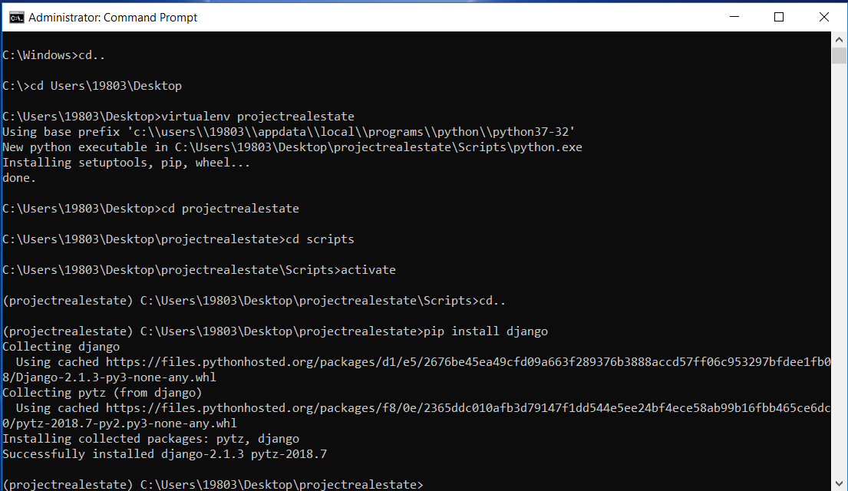

1. **Create a project homefinder inside the virtualenv-**

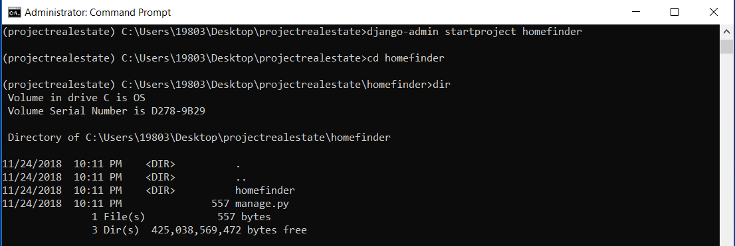

1. **Create an app inside the homefinder so navigate to the folder and type the command-**

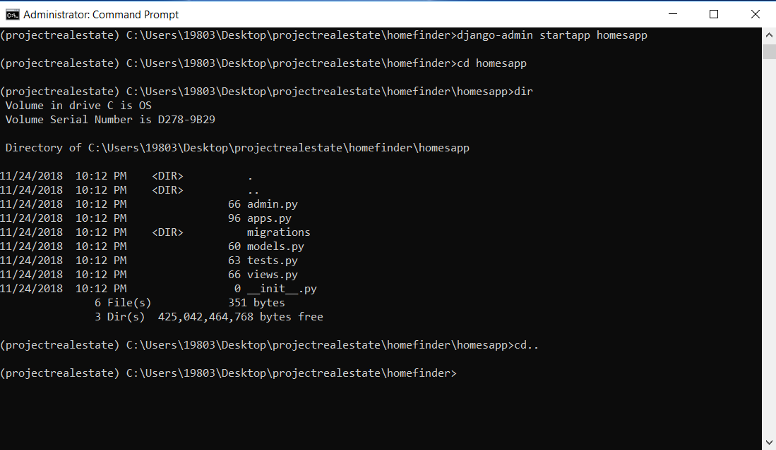

1. **Start server**

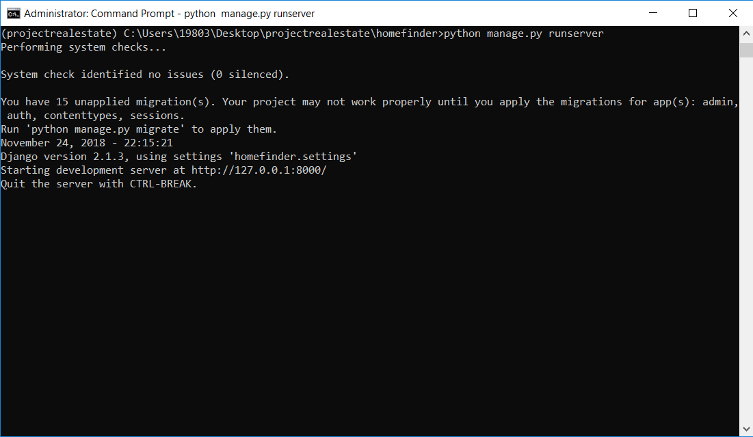

1. **Copy the server path into the browser and see whether the project was successfully created**

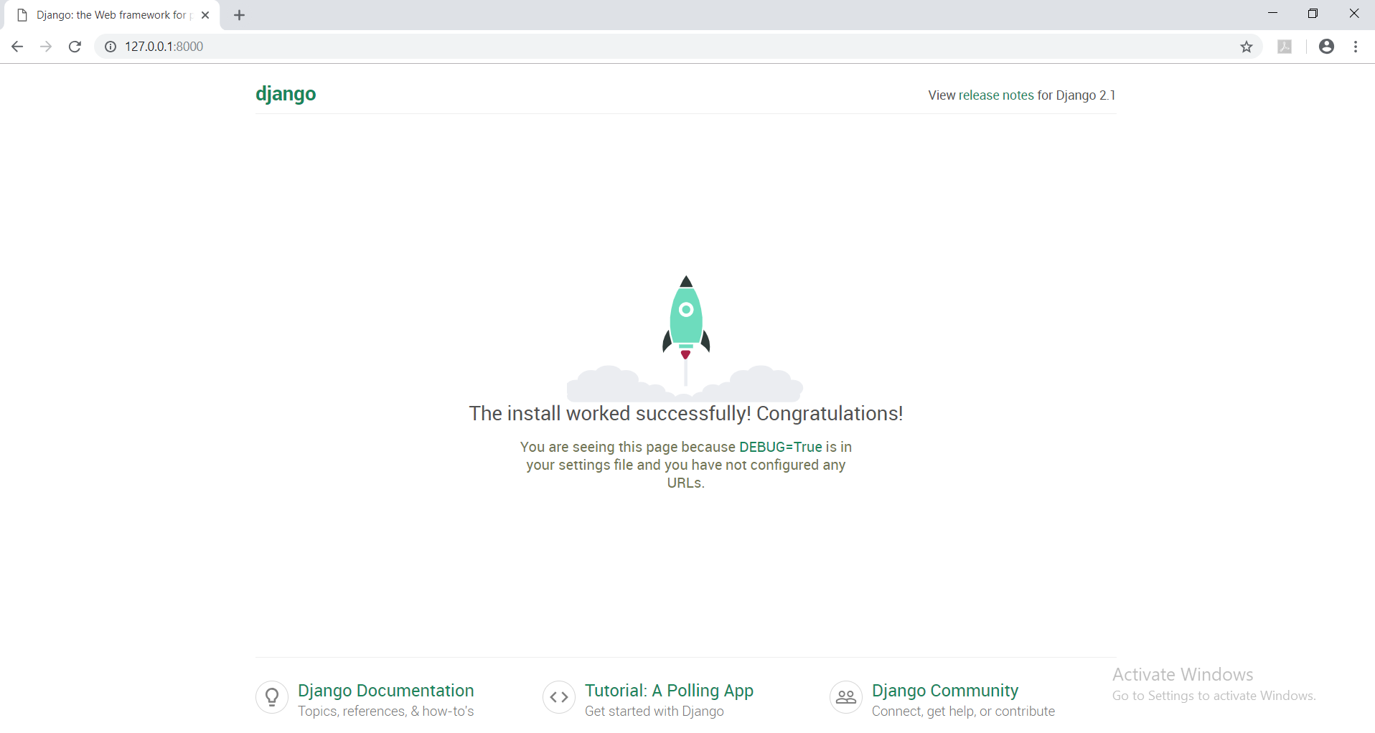

1. **Create models for the project**

Open project folder in Visual Studio IDE.

Go to the models.py folder

Create the models as follow-

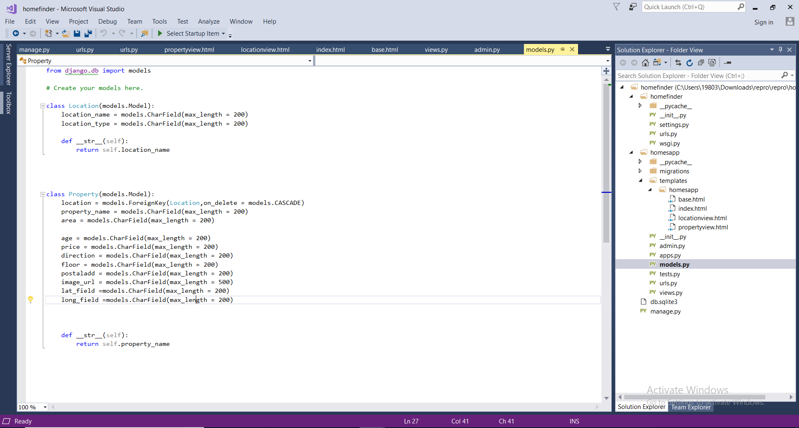

1. **Create admin for Django**

Type the command

python manage.py createsuperuser

enter the name password and email for the user and hit enter.

Runserver by typing the command

Python manage.py runserver

<http://127.0.0.1:8000/admin> copy this link to the browser and a dashboard will open for admin to login

1. **Create Views for the project**

Go to the views.py file and create views.

Create template folder in the homesapp.

Create a folder with the homesapp

Create a html file

And In the views.py specify the html file name to be used as template.

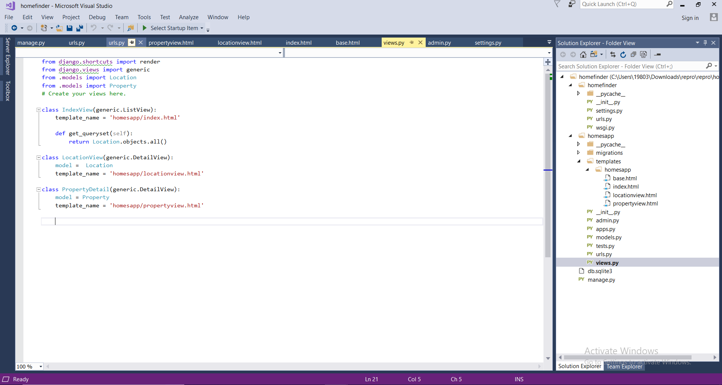

1. **Open urls.py to set the webpages for the website**

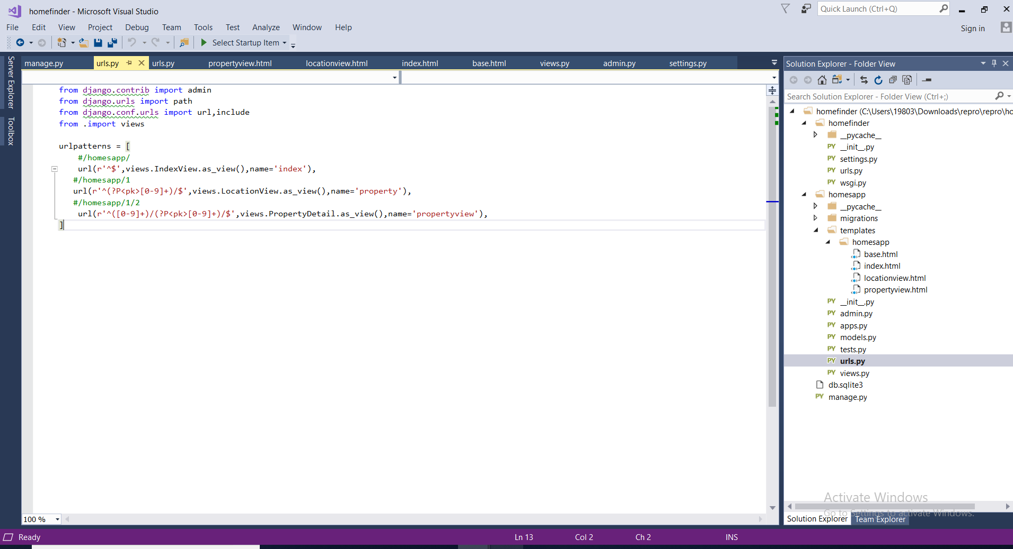

1. **Get API key for the maps**

Go to developers.google.com

**Create a new project**

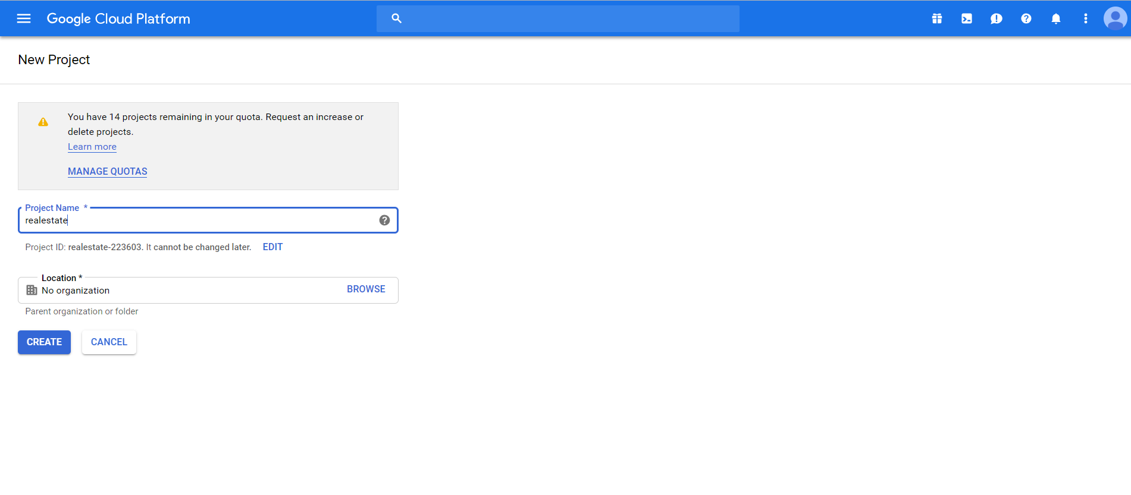

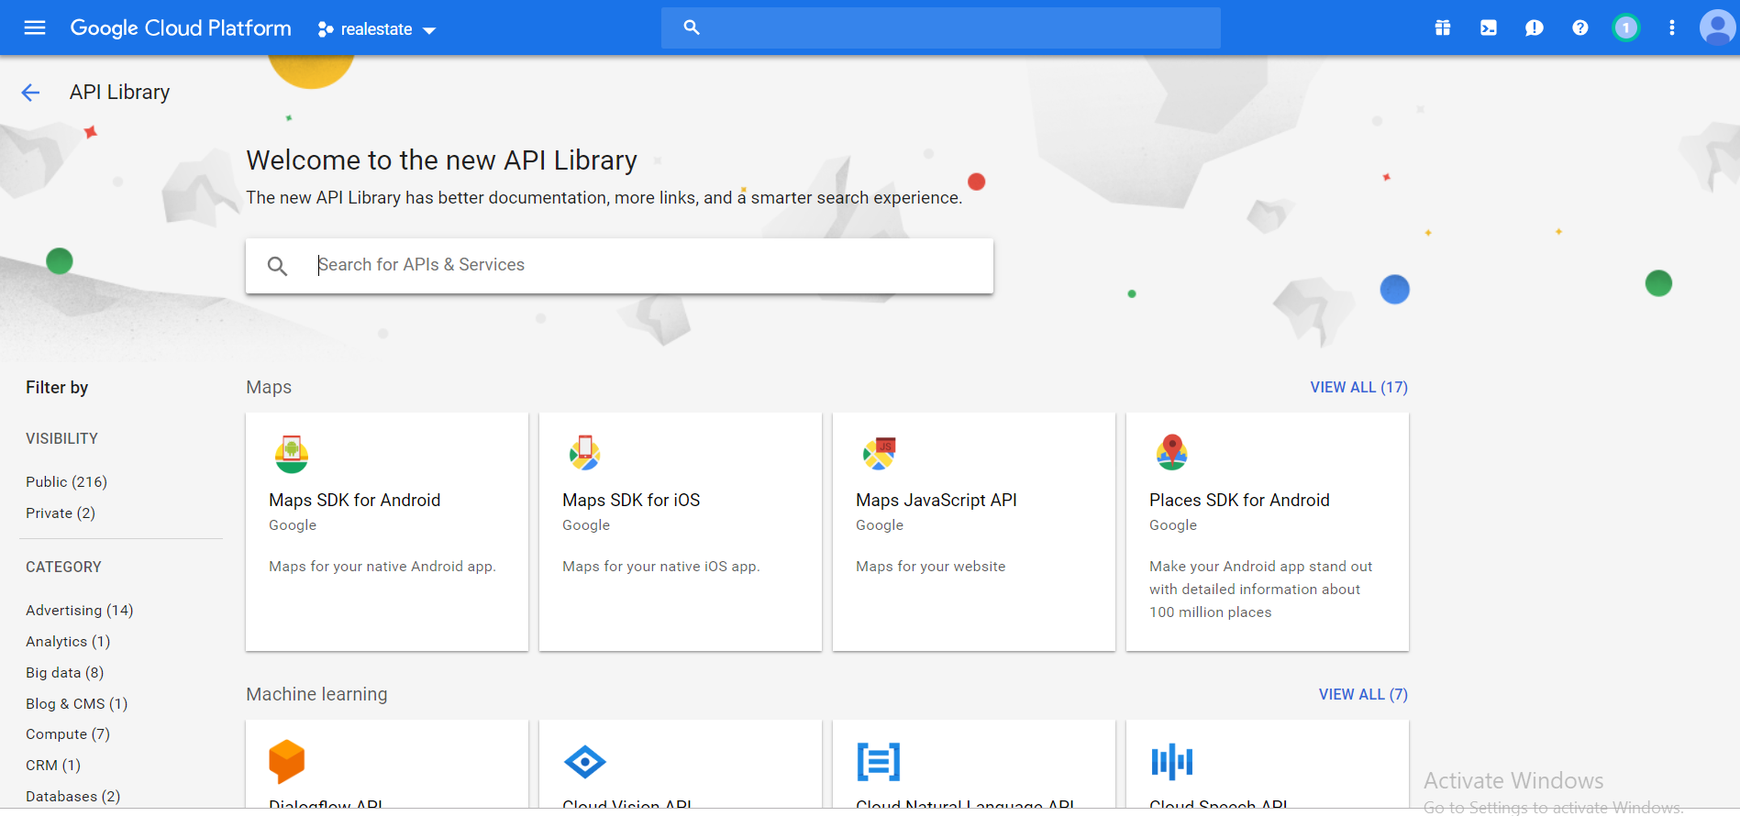

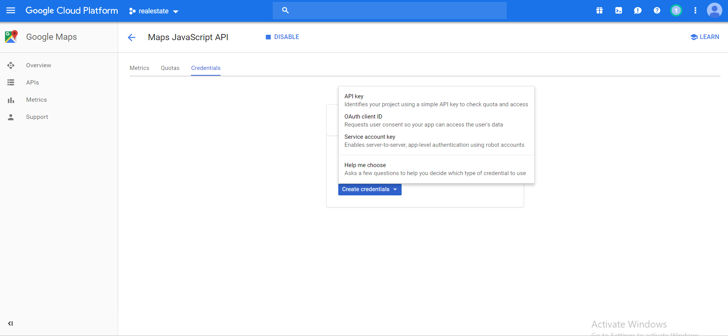

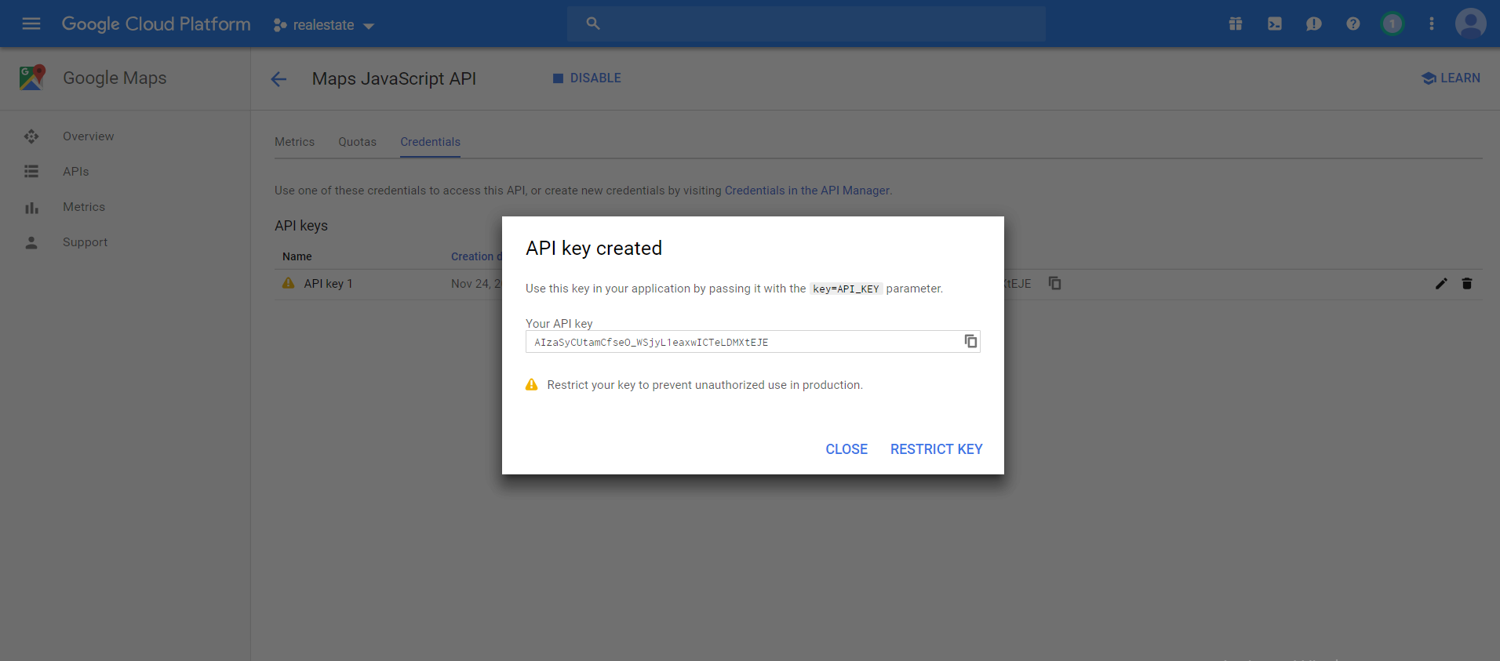

**Run the website as-**

**Main Page**

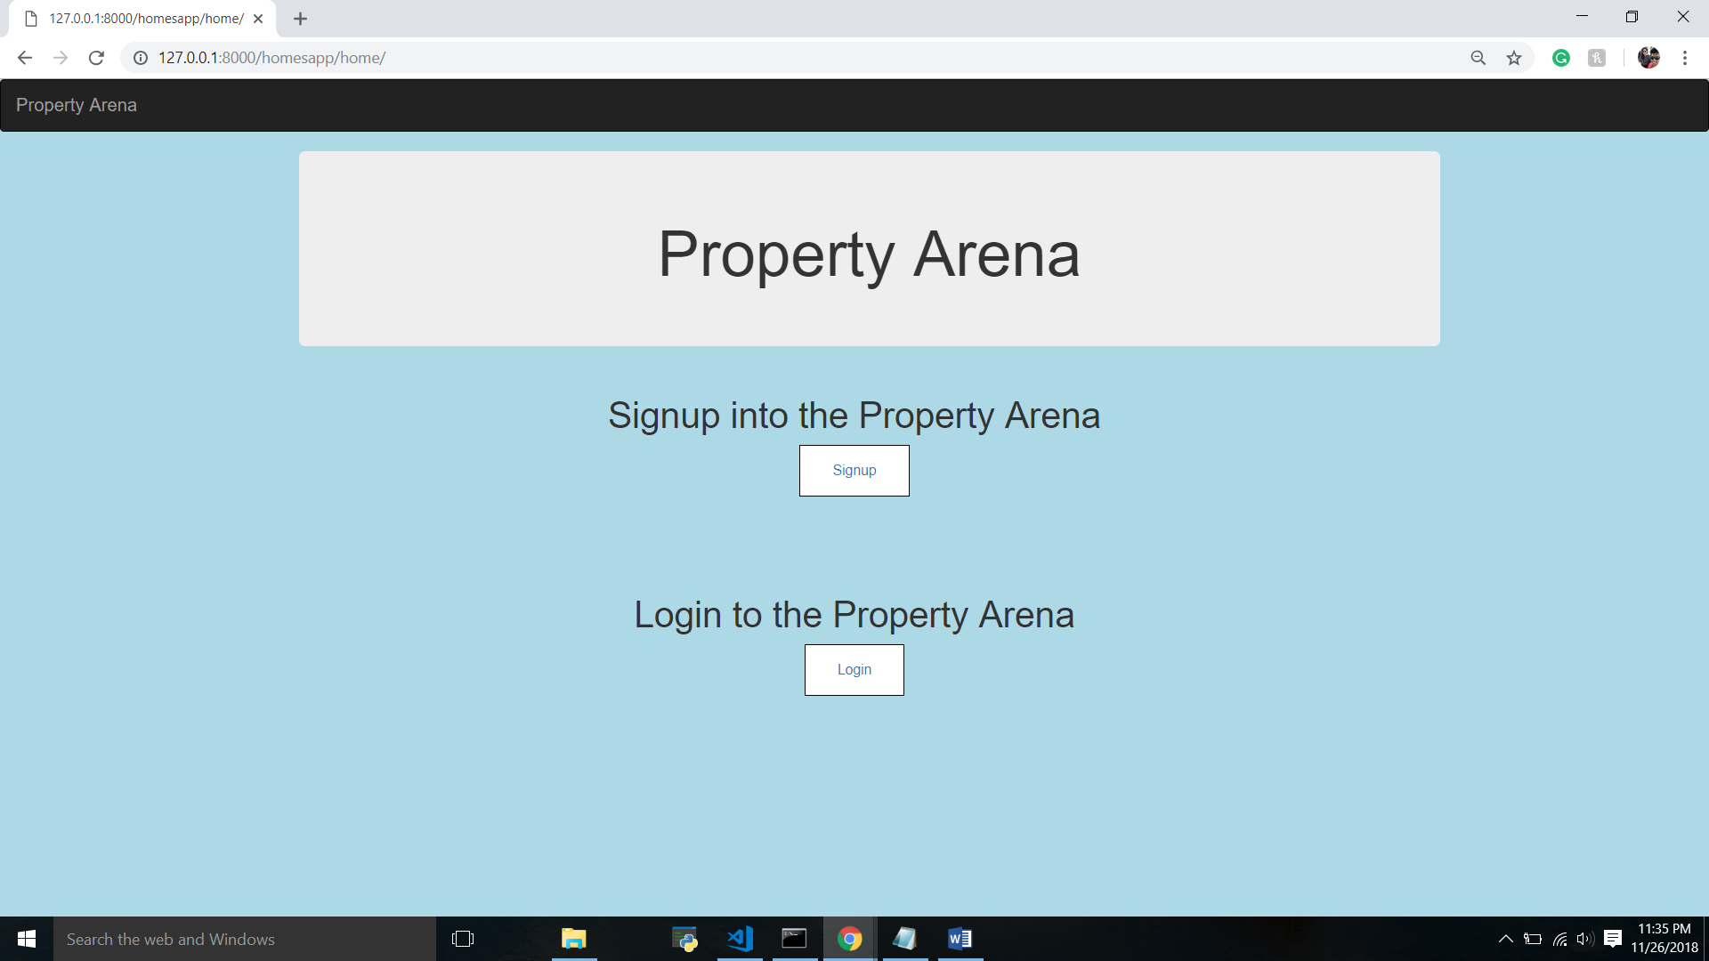

**Signup page**

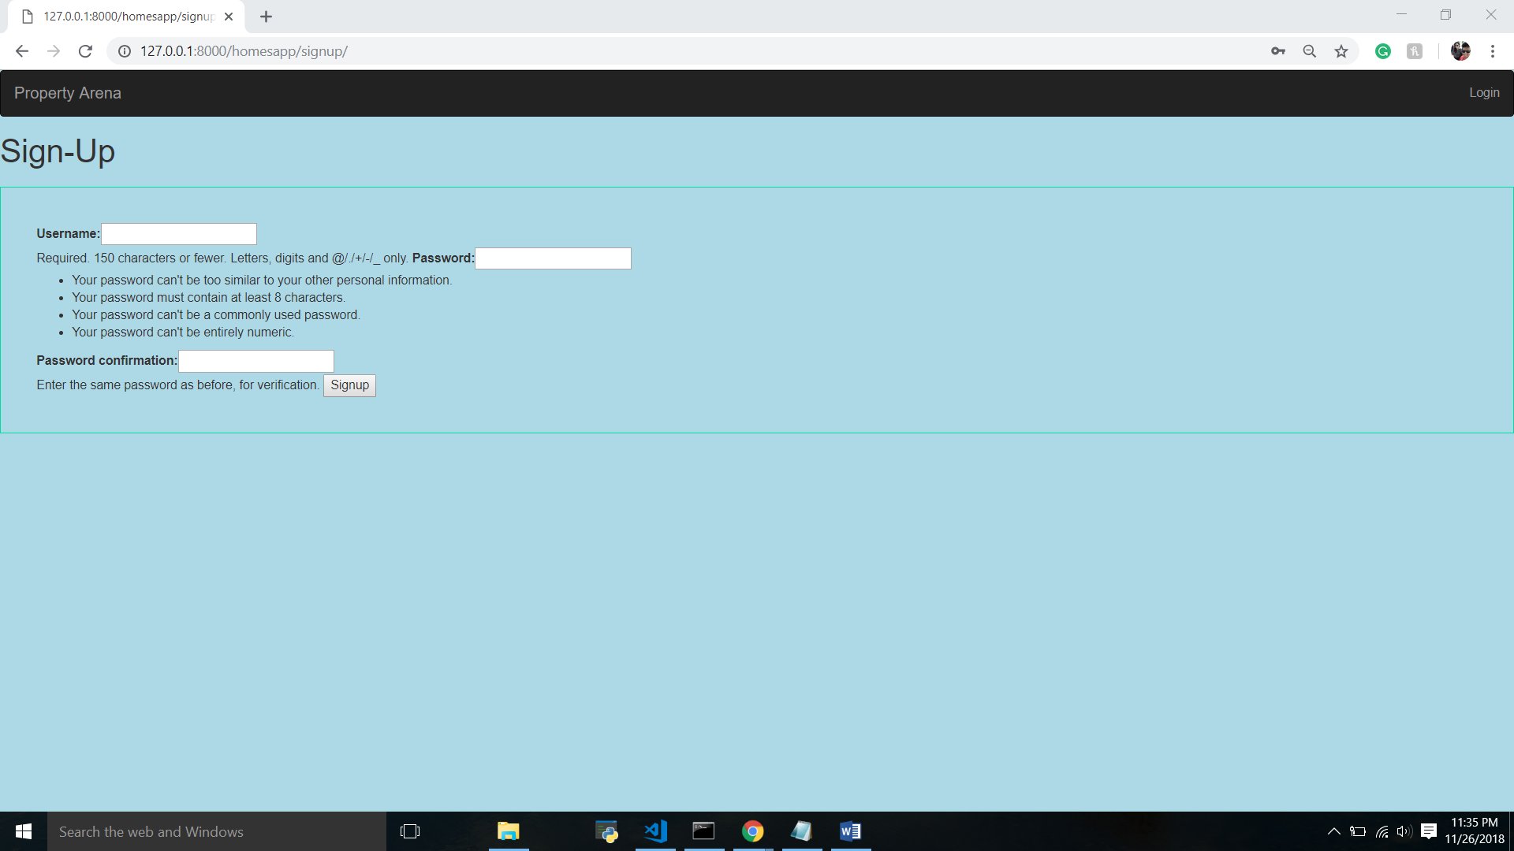

**Login page**

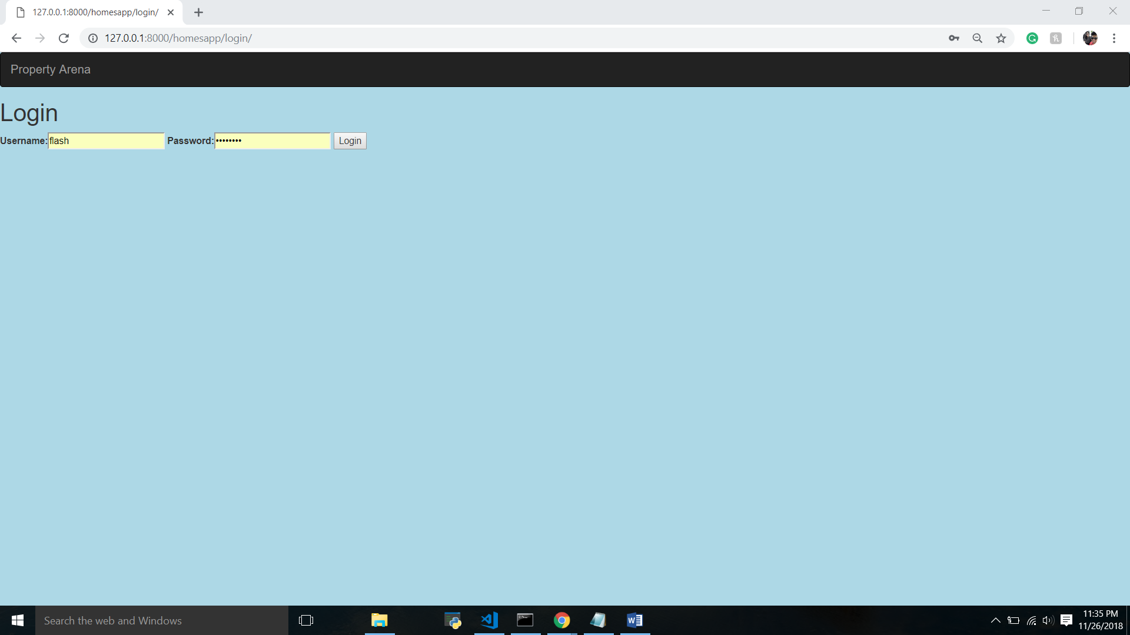

**Home Page**

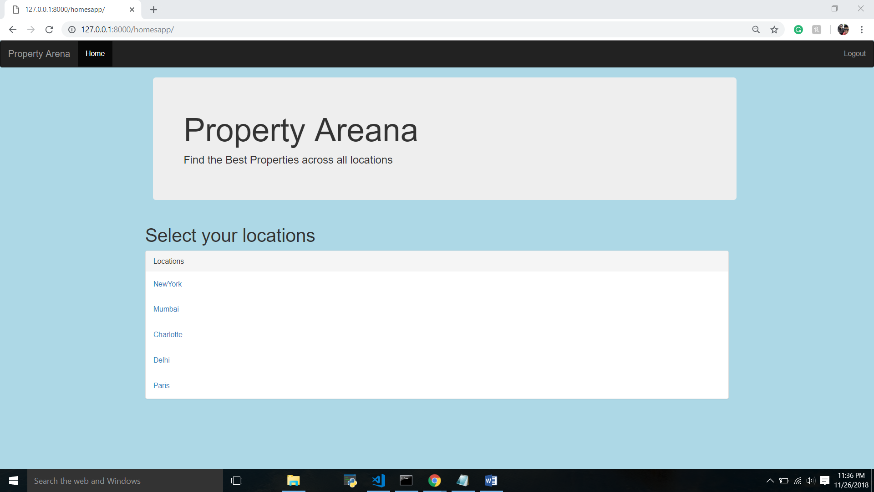

**Properties in a particular location (Location View)**

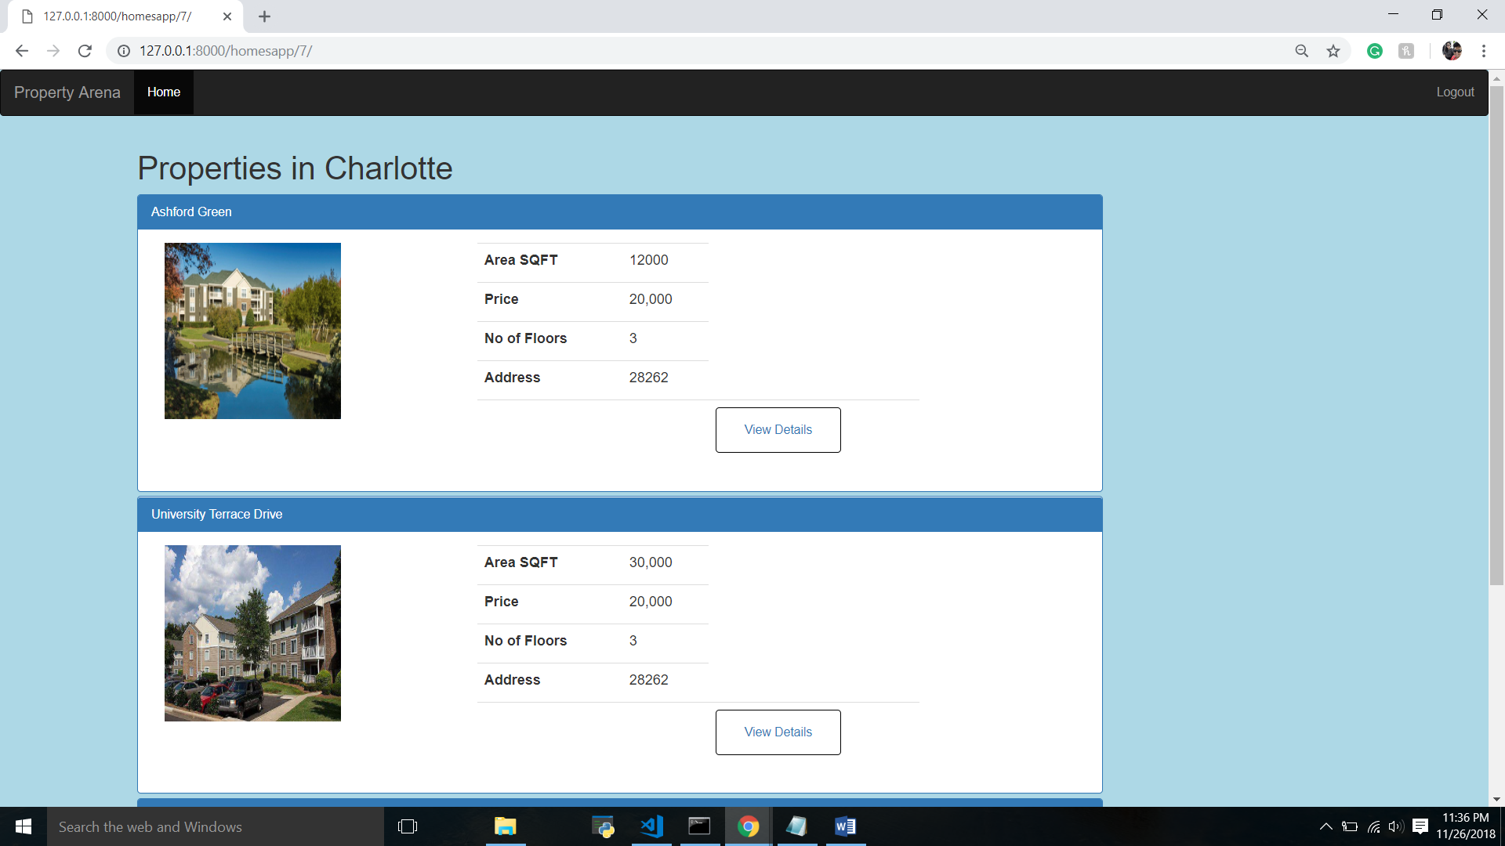

**Property Details (Property View)**

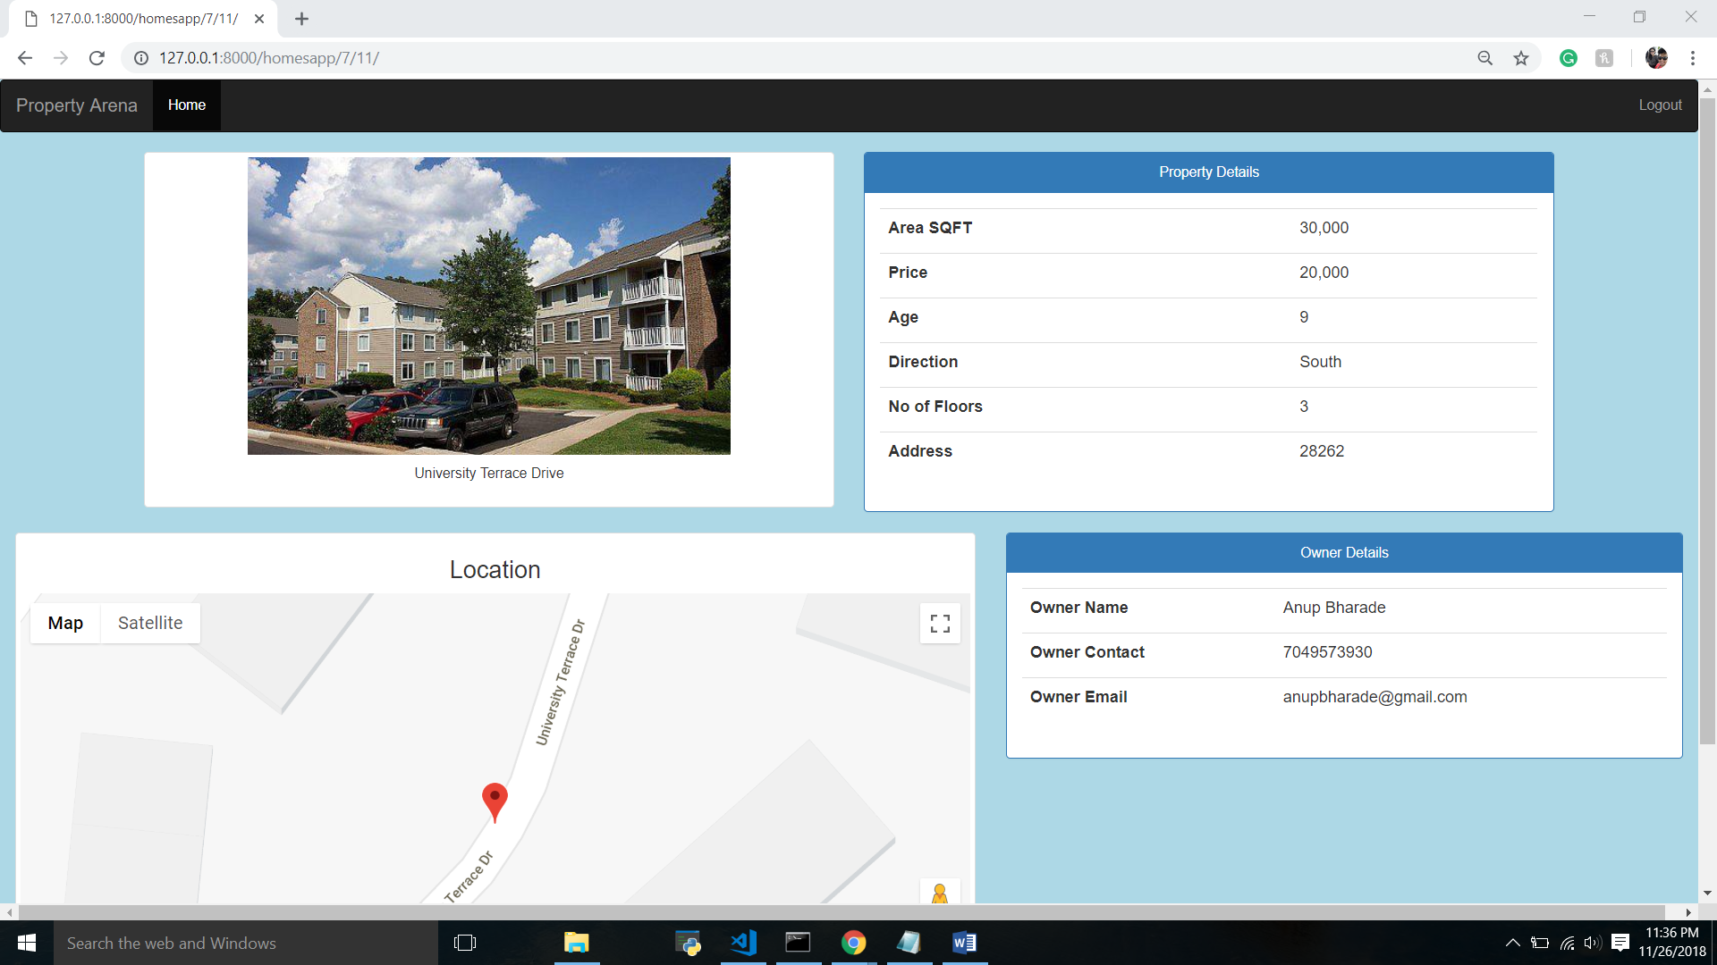

**Google Map location for the property**

